www.ccacregistry.org
The OEC Early Childhood Professional Registry (formerly Connecticut Charts-A-Course)
Screen shots to help family child care providers set up a Registry account
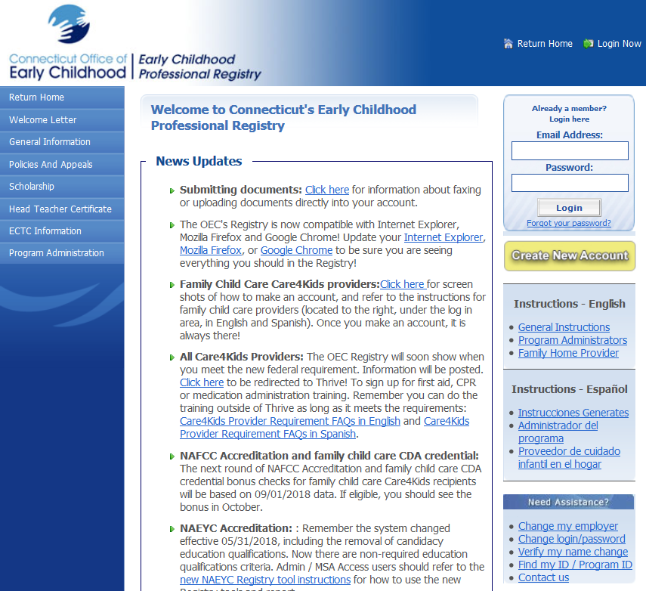

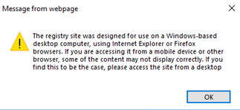
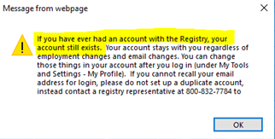
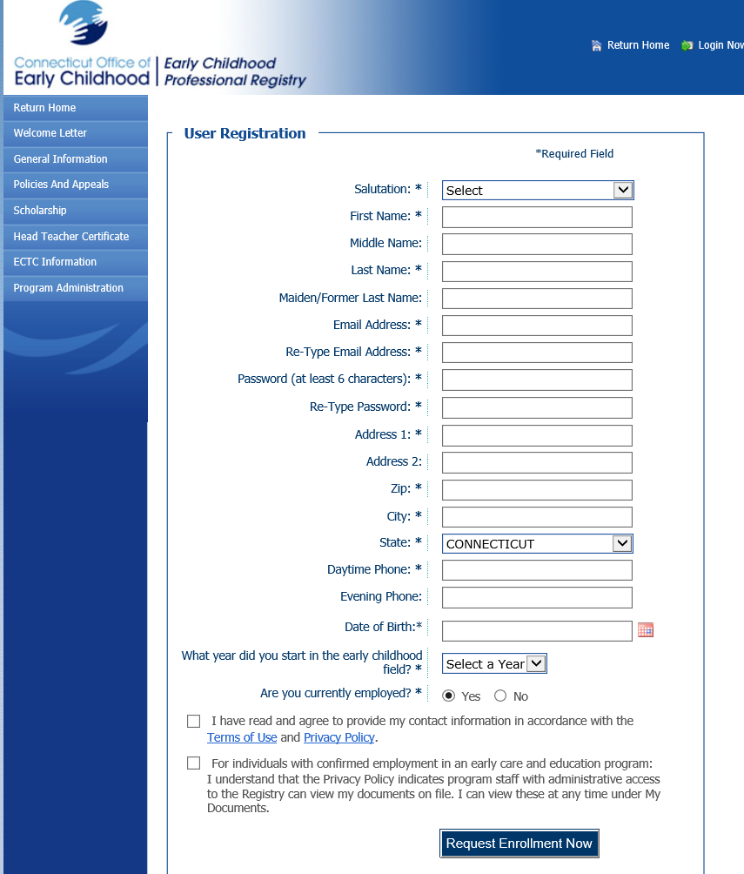

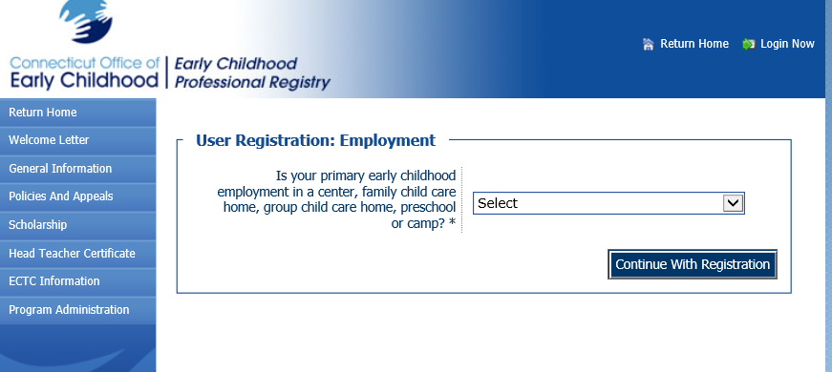

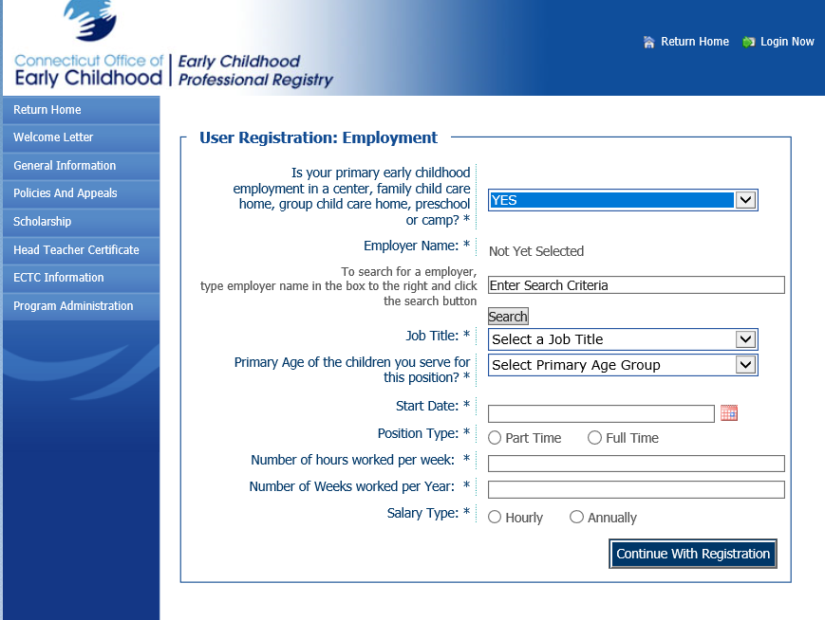

If Unlicensed family provider: type and select Unlicensed Family Care Home.
For position /role: Unlicensed Family Home Provider.

If licensed family home provider (DCFH): your program name is your first name last name (as they appear for your OEC license; if unsure check eLicense) and Family Child Care Home.
For example: Mary Bean Family Child Care Home.
Type your first and last name in the search box. Select and save.

For position / role: choose either Family Home Provider Director OR Family Home Provider Assistant.

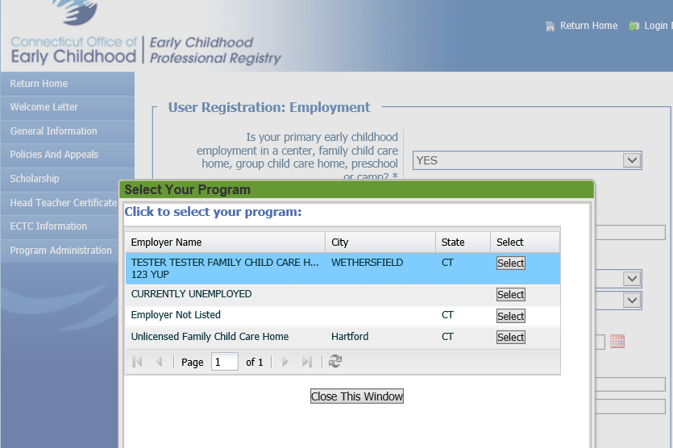

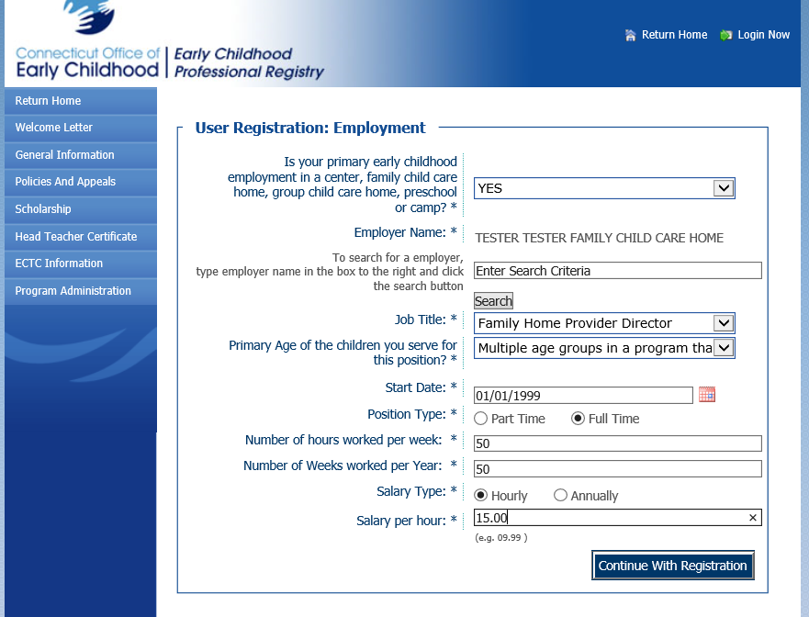
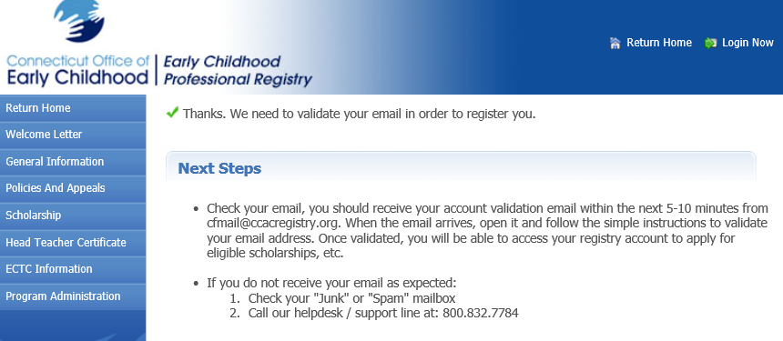

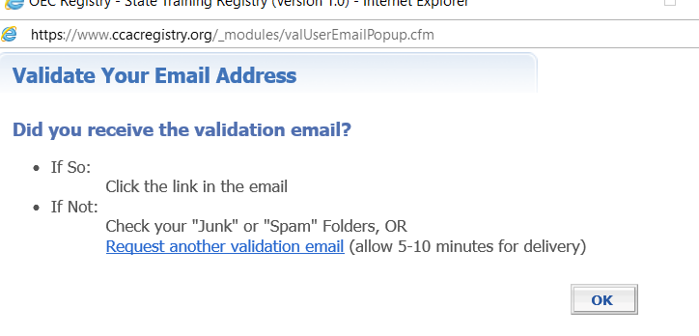

If you are an Unlicensed Family Home Provider, your account is set up. Your program ID# is located on your Education and Training Report.
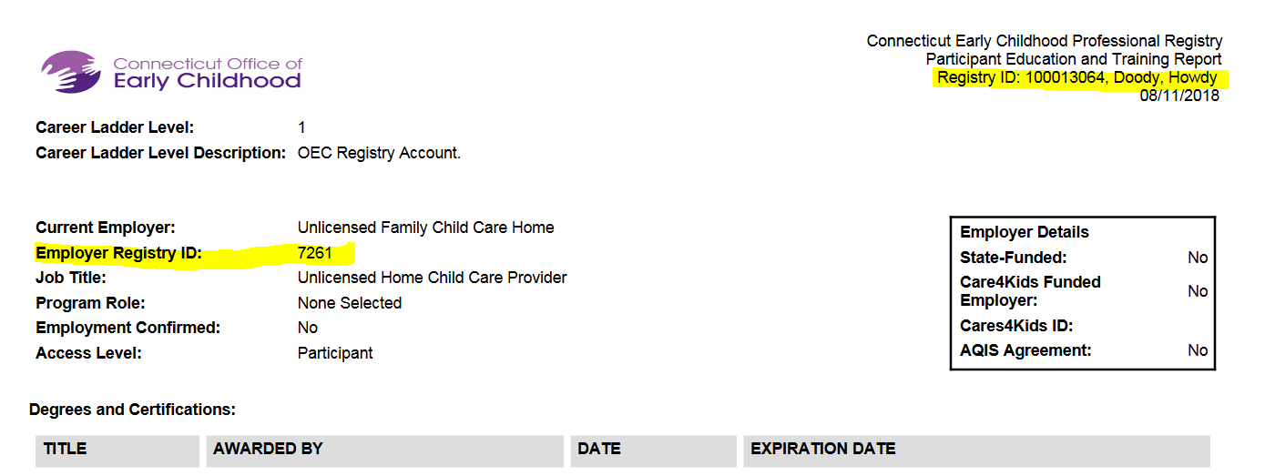

If you have a DCFH program, please go to the next page.

For DCFH programs:
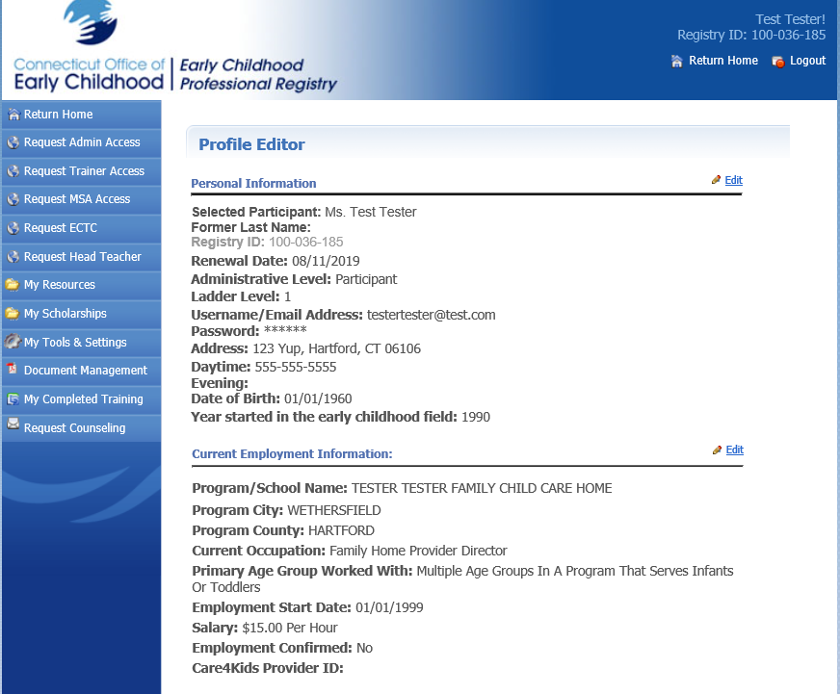
Request Admin Access
You do not need to submit documentation of your owning the business so long as the names on the account and the license match.

When your access is approved (you will receive an email): log in to your account, go to Program Administration: Staff Confirmation, and confirm your employment and that of any assistants you employ.
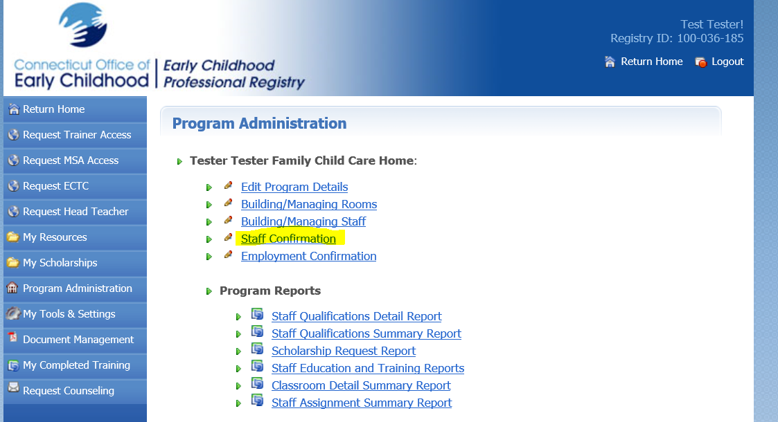
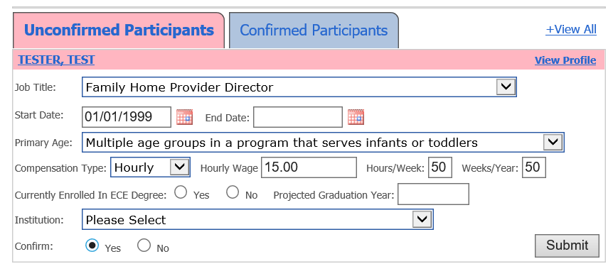

Your program ID # is located on your Education and Training Report. You will see that your employment is confirmed.
